University Database

Database Systems and SQL

CSCI-2215-01/6622-01

Analytical Control



University of New Haven

TAGLIATELA COLLEGE OF ENGERNEERING, West Haven, CT

Submitted to:

Dr. Reza Sadeghi

Spring 2021

Analytical Control

Analytical Control

Hugh-John Dunkley: [hdunk1@unh.newhaven.edu](mailto:hdunk1@unh.newhaven.edu)

Rogan Gopi: [rgopi1@unh.newhaven.edu](mailto:rgopi1@unh.newhaven.edu)

Grace Mandada: [gmand3@unh.newhaven.edu](mailto:gmand3@unh.newhaven.edu)

Bhargavi Gottumukkula: [gbhar1@unh.newhaven.edu](mailto:gbhar1@unh.newhaven.edu)

Samuel Mandada: [smand17@unh.newhaven.edu](mailto:smand17@unh.newhaven.edu)

Team Roles

* Hugh-John Dunkley

Team Leader, coordinator, researcher, designer

* Rogan Gopi

Developer, Graphical User interface designer

* Grace Mandada

Graphical user interface connector and researcher

* Samuel Mandada

Graphical user interface connector and researcher

* Bhargavi Gottumukkula

Database manager and researcher

Table of Contents

Introduction……………………………………………………..……… 4

Entity Relationship Model………………..……………………………. 4

Creating Database in the MySQL at a glance…...……………..………. 5

Python code explanation ……………….……………………………… 7

Project perquisites……………….………...…………………………… 8

Implementation…………………………………………………………………………………. 9

Conclusion……………………………………………………………………………………….. 39

**INTRODUCTION**:

The main goal of our project is to create a university database which contains the details about the Students, Faculties, departments, Courses using MySQL and in order to access the details or search them efficiently, GUI was created using Tkinter (Python).

**ENTITY RELATIONSHIP MODEL:**

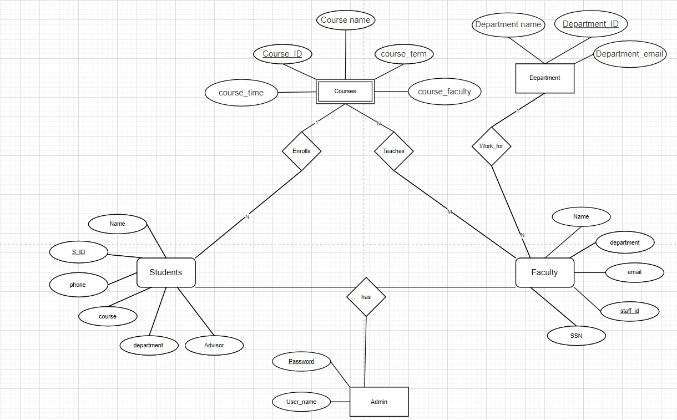

Fig:1 Entity relationship model for univ_database

The entity relationship model depicts how each and other entities were related to and it give visual idea how the entities in the database were connected with some specific details such as weak entity, strong entity, and so on.

**CREATING DATABASE IN THE MYSQL AT A GLANCE:**

The MySQL software was downloaded from MySQL community server with the specific operating system selected. As the next step is to install MySQL workbench to work with the database. In fact there are many ways to acces the SQL server like terminal, command prompt, we explicitly installed workbench to work hassle free and for more GUI experience.

Once all these were installed, we started creating the database named “univ-database” in our local instance. The command used to create the database is : “create database univ_database;”

But before that we have to double check whether any other database was created in that same name. To simply check type, “show database;”

**CREATING STUDENT TABLE AND ADDING VALUES:**

**CREATE** **TABLE** student(

id VARCHAR(20) NOT NULL,

name VARCHAR(20) NOT NULL,

phone VARCHAR(10) NOT NULL,

course VARCHAR(20) NOT NULL,

department VARCHAR(20) NOT NULL,

Advisor VARCHAR(20) NOT NULL);

**INSERTING VALUES TO THE STUDENT TABLE:**

**insert** **into** student **values**(001,'mike',2034556677,'database','computer science','michael')

,(002,'steven',2034556678,'hacking','Cyber Security','mark')

,(003,'lewis',2034556679,'statistics','industrial','john')

,(004,'stuart',2034556680,'const_modeling','civil','george')

,(005,'stuart',2034556681,'cell biology','Bio Technology','greg');

**CREATING FACULTY TABLE AND ADDING VALUES:**

**CREATE** **TABLE** faculty(

staff_id VARCHAR(20) NOT NULL,

name VARCHAR(20) NOT NULL,

ssn VARCHAR(20) NOT NULL,

department VARCHAR(20) NOT NULL,

email VARCHAR(20) NOT NULL);

**INSERTING VALUES TO THE FACULTY TABLE:**

**insert** **into** faculty **values**(101,'michael',56455467,'computer science','mic@gmail.edu')

,(102,'mark',99886545,'Cyber security','mark@gmail.edu')

,(103,'john',22324356,'industrial','john@gmail.edu')

,(104,'george',76568900,'civil','george@gmail.edu')

,(105,'greg',67586758,'Bio Technology','greg@gmail.edu');

**CREATING DEPARTMENT TABLE AND ADDING VALUES:**

**CREATE** **TABLE** department(

dept_id VARCHAR(20) NOT NULL,

dept_name VARCHAR(20) NOT NULL,

dept_email VARCHAR(20) NOT NULL);

**INSERTING VALUES TO THE DEPARTMENT TABLE:**

**insert** **into** department **values**(200,'computer science','cs@info.edu')

,(201,'cyber security','cyber@info.edu')

,(203,'industrial','indust@info.edu')

,(204,'civil','civil@info.edu')

,(205,'Bio Technology','bio@info.edu');

**CREATING COURSE TABLE AND ADDING VALUES:**

course_id VARCHAR(20) NOT NULL,

course_name VARCHAR(20) NOT NULL,

course_term VARCHAR(20) NOT NULL,

course_faculty VARCHAR(20) NOT NULL,

course_time VARCHAR(20)NOT NULL);

**INSERTING VALUES TO THE COURSE TABLE:**

insert into course values(601,'database','spring','michael','3:30-6:30')

,(602,'hacking','fall','mark','1:30-3:30')

,(603,'statistice','spring','john','2:30-5:30')

,(604,'const_modeling','spring','george','10:30-2:30')

,(605,'cell biology','fall','greg','8:30-10:30');

The step is to link the database with the python. The command used to link is :

“pip3 install mysql-connector-python”

A sample code was written to check the database was linked to the python.

**import** mysql.connector

db =mysql.connector.connect(

host='localhost',

user='root',

password='rootroot',

database='univ_database'

)

mycursor = db.cursor()

mycursor.execute('select count(*) from students;')

**for** x **in** mycursor:

**print**(x)

Upon success connection, we started writing the python program to implement the GUI.

**PYTHON CODE EXPLANATION:**

We have used programming language called “python” to build a database system. Python offers various utilities to design the GUI (Graphical User Interface), and one such utility is Tkinter. Using Tkinter, we have designed the GUI for the university database system.

The outline of university database management system will look like this

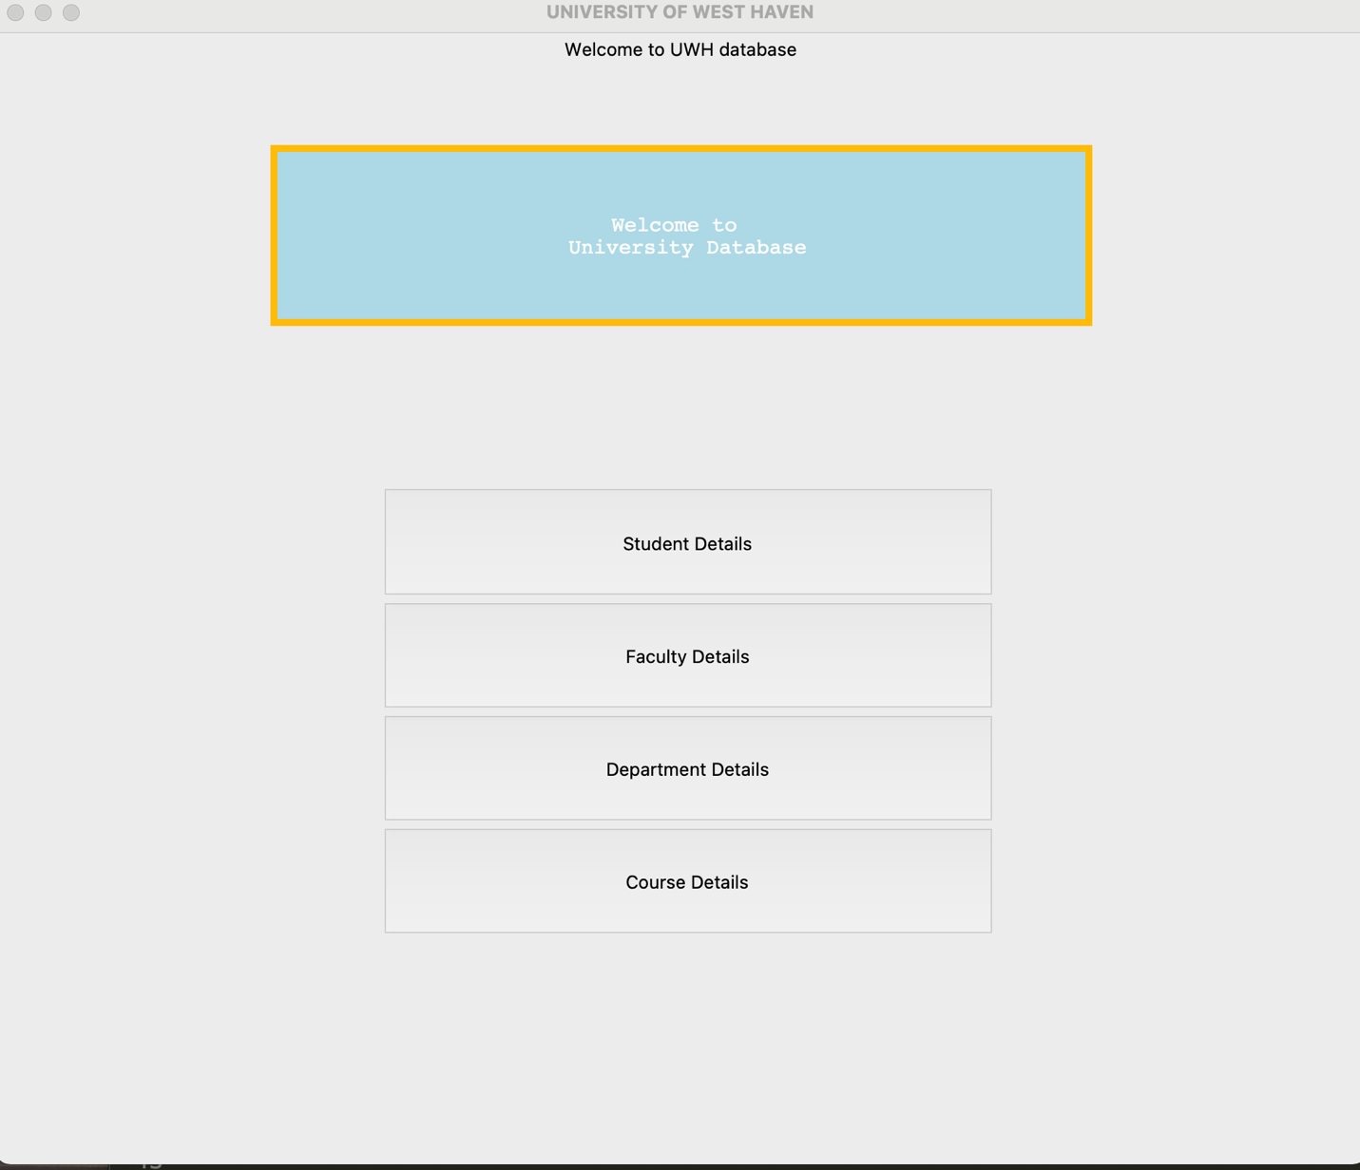

Fig: - University Database System

PROJECT PERQUISITES:

To use the tkinter utility in our python code, we have installed tkinter library in our system. Install Tkinter by using this command,

“Pip install Tkinter “

To communicate with our database system through python code, we have installed MySQL connector library. Install MySQL by using this command,

“Pip install mysql”

“pip3 install mysql-connector-python”

**Database creation:**

Before getting into the python code, we are required to install the MySQL Server database on our system to make mysql library work.

MySQL Server Installation

Download Link - <https://dev.mysql.com/downloads/mysql/>

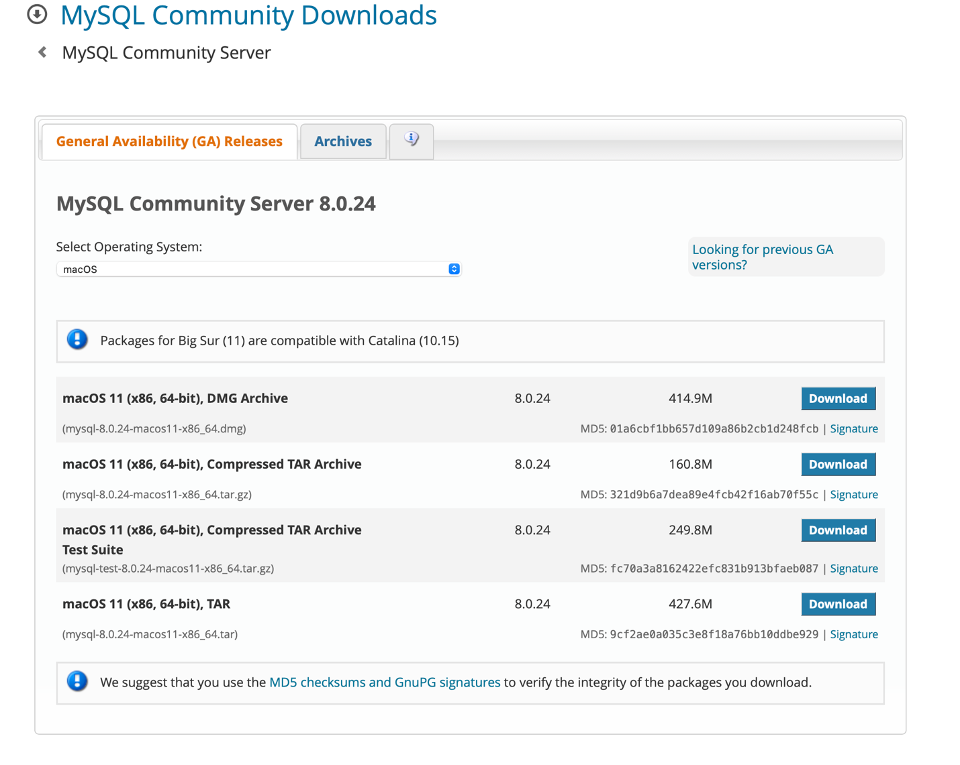

Fig: - MySQL Community server

**MYSQL WORKBENCH INSTALLATION:**

Download Link - <https://dev.mysql.com/downloads/workbench/>

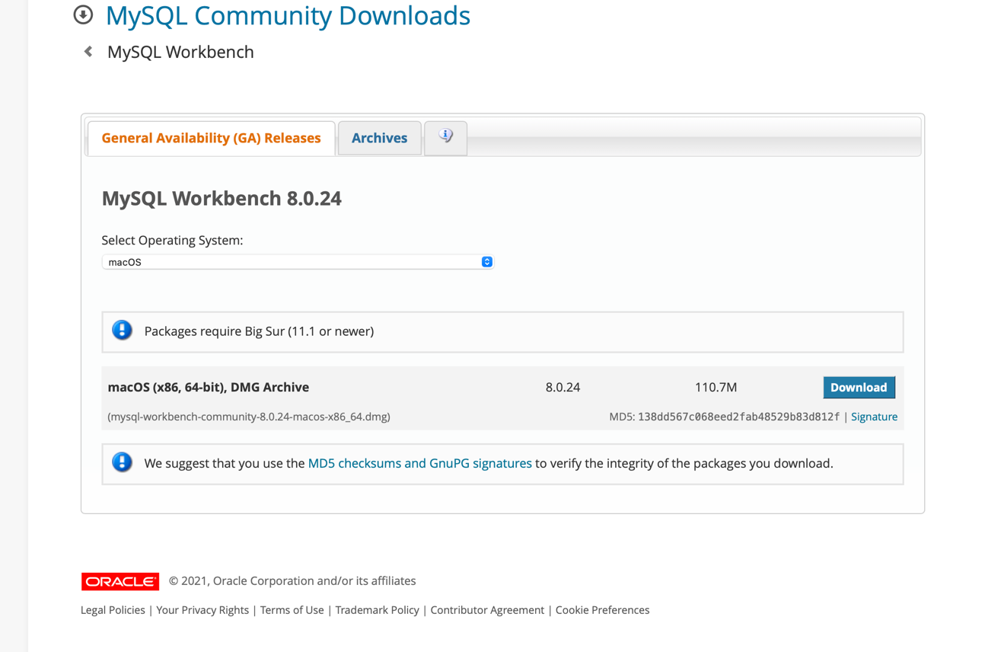

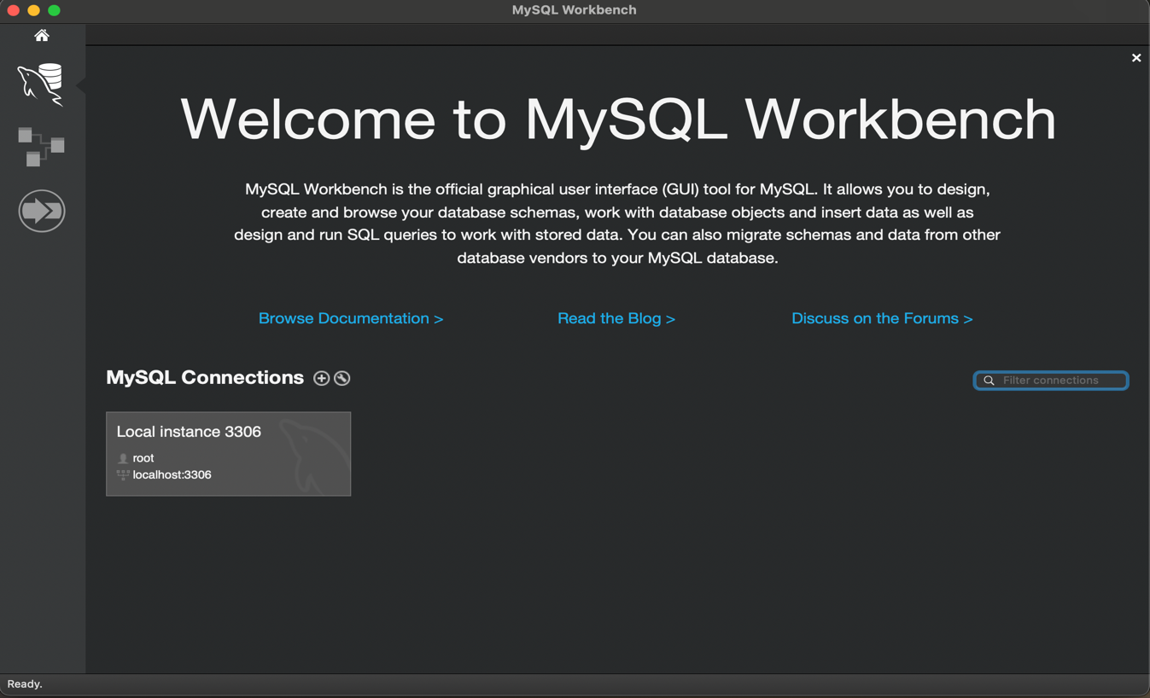Fig: - MySQL Workbench

After we configured our MySQL workbench database, it will prompt us to enter the username and password to login into our DB instance.

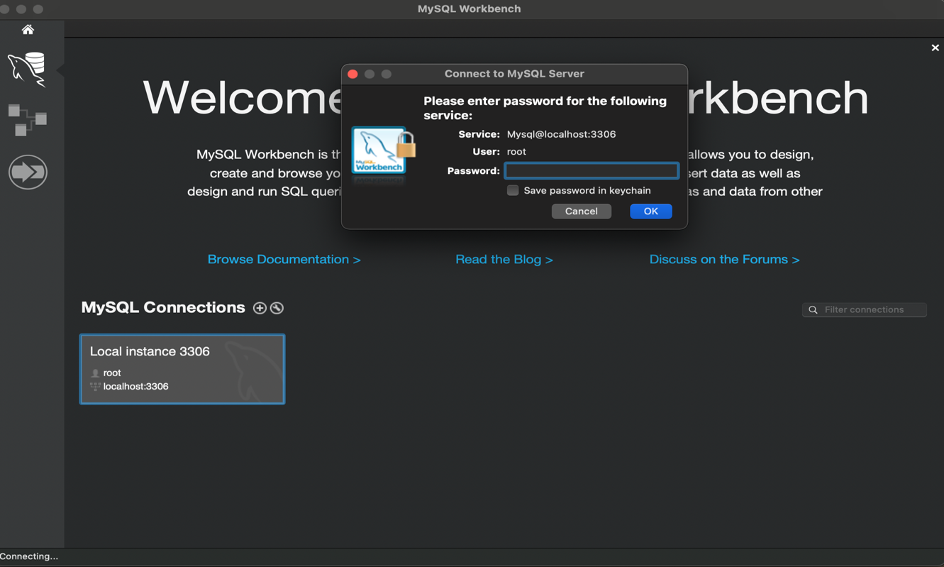

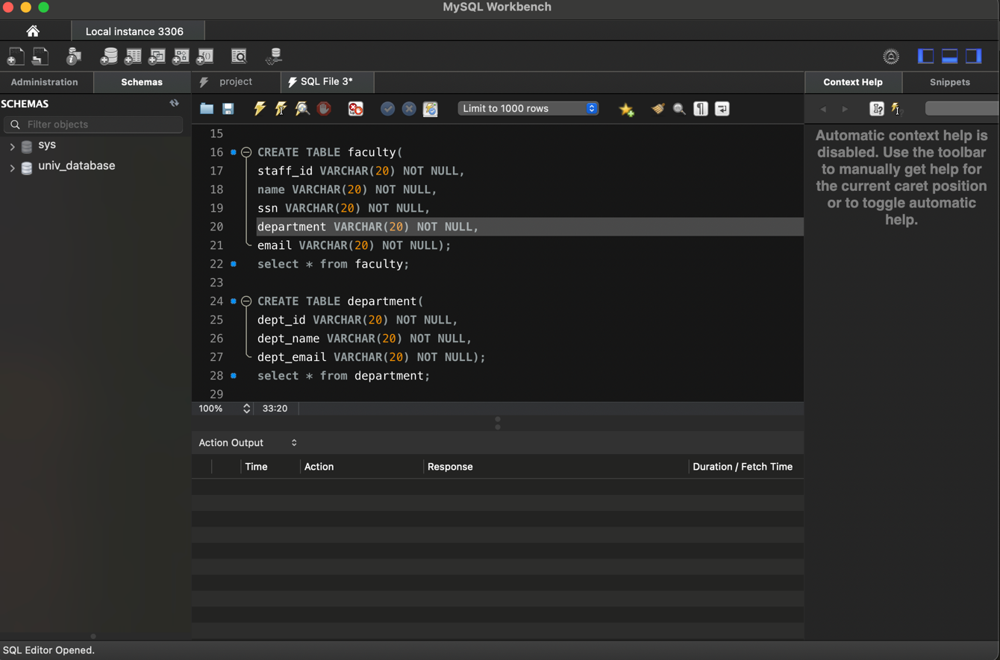

We have created the database called “univ_database”. We also created 4 tables in our database for each section i.e.

1. Student
2. Faculty
3. Department
4. Course

Creating database and tables using the following MySQL Command

show databases;

use univ_database;

show tables;

drop table student;

CREATE TABLE student(

**id** VARCHAR(20) **NOT** NULL,

name VARCHAR(20) **NOT** NULL,

phone VARCHAR(10) **NOT** NULL,

course VARCHAR(20) **NOT** NULL,

department VARCHAR(20) **NOT** NULL,

Advisor VARCHAR(20) **NOT** NULL);

desc student;

select * **from** student;

drop table faculty;

CREATE TABLE faculty(

staff_id VARCHAR(20) **NOT** NULL,

name VARCHAR(20) **NOT** NULL,

ssn VARCHAR(20) **NOT** NULL,

department VARCHAR(20) **NOT** NULL,

email VARCHAR(20) **NOT** NULL);

select * **from** faculty;

CREATE TABLE department(

dept_id VARCHAR(20) **NOT** NULL,

dept_name VARCHAR(20) **NOT** NULL,

dept_email VARCHAR(20) **NOT** NULL);

select * **from** department;

CREATE TABLE course(

course_id VARCHAR(20) **NOT** NULL,

course_name VARCHAR(20) **NOT** NULL,

course_term VARCHAR(20) **NOT** NULL,

course_faculty VARCHAR(20) **NOT** NULL,

course_time VARCHAR(20)**NOT** NULL);

select * **from** course;

Description of Project Files

Below are the project files you will get once you download and extract the project file:

* **test.py** – which does function call to all other python files
* **student.py** – CRUD operation for the students
* **faculty.py** – CRUD operation for the faculty
* **course.py** – CRUD operation for the course
* **department.py** – CRUD operation for the department

test.py

**from** tkinter **import** *

**from** PIL **import** ImageTk,Image

**from** tkinter **import** messagebox

**import** mysql.connector **as** mysql

**from** login **import** *

**from** faculty **import** *

**from** department **import** *

**from** course **import** *

mypass = "rootroot"

mydatabase="univ_database"

con = mysql.connect(host="localhost",user="root",password=mypass,database=mydatabase)

cur = con.cursor()

root = Tk()

root.title("UNIVERSITY OF WEST HAVEN")

root.minsize(width=500,height=500)

root.geometry("700x600")

label = Label(root, text = "Welcome to UWH database",fg = "black").pack()

#icon = PhotoImage(file = "/Users/gokulsd/Desktop/Rogan/Gokul/image.jpeg")

#label = Label(root, image = icon)

#xqlabel.pack()

headingFrame1 = Frame(root,bg="#FFBB04",bd=5)

headingFrame1.place(relx=0.2,rely=0.1,relwidth=0.6,relheight=0.16)

headingLabel = Label(headingFrame1, text="Welcome to \n University Database", bg='light blue', fg='white', font=('Courier',15))

headingLabel.place(relx=0,rely=0, relwidth=1, relheight=1)

btn1 = Button(root,text="Student Details",bg='red', fg='black',command=stud)

btn1.place(relx=0.28,rely=0.4, relwidth=0.45,relheight=0.1)

btn2 = Button(root,text="Faculty Details",bg='black', fg='black',command=fac_login)

btn2.place(relx=0.28,rely=0.5, relwidth=0.45,relheight=0.1)

btn3 = Button(root,text="Department Details",bg='black', fg='black',command=dep_login)

btn3.place(relx=0.28,rely=0.6, relwidth=0.45,relheight=0.1)

btn4 = Button(root,text="Course Details",bg='black', fg='black',command=course_login)

btn4.place(relx=0.28,rely=0.7, relwidth=0.45,relheight=0.1)

root.mainloop()

Output:

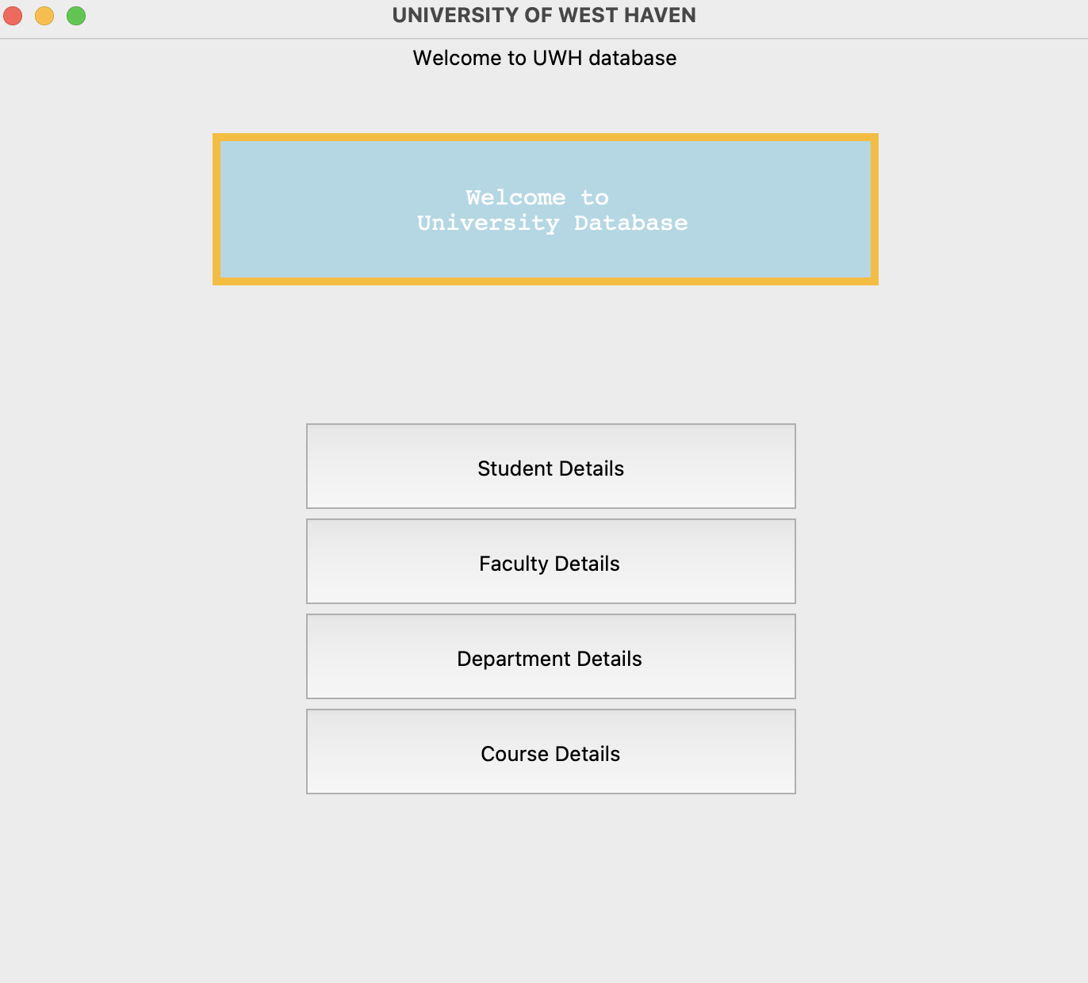

Student.py

**from** tkinter **import** *

**from** tkinter **import** messagebox

**import** mysql.connector **as** mysql

**def** success():

uname= e1.get()

password=e2.get()

**if**(uname == "" **and** password == ""):

messagebox.showinfo("", "Please fill all fields")

**elif**(uname == "Admin" **and** password == "12345"):

messagebox.showinfo("", "Login Success")

details();

**else**:

messagebox.showinfo("", "Incorrect username and password")

**def** details():

**global** e_id,e_name,e_phone,e_course,e_dept,e_advisor

root = Tk()

root.title("UNIVERSITY OF NEW HAVEN")

root.minsize(width=500,height=500)

root.geometry("700x600")

**ID** = Label(root,text="Enter ID").place(x=20,y=30)

name = Label(root,text="Enter Name").place(x=20,y=60)

phone = Label(root,text="Enter Mobile No.").place(x=20,y=90)

course = Label(root,text="Enter Course").place(x=20,y=120)

department = Label(root,text="Enter Department").place(x=20,y=150)

Advisor = Label(root,text="Enter Advisor Name").place(x=20,y=180)

e_id = Entry(root)

e_id.place(x=150, y=30)

e_name = Entry(root)

e_name.place(x=150, y=60)

e_phone = Entry(root)

e_phone.place(x=150, y=90)

e_course = Entry(root)

e_course.place(x=150, y=120)

e_dept = Entry(root)

e_dept.place(x=150, y=150)

e_advisor = Entry(root)

e_advisor.place(x=150, y=180)

Button (root,text= "insert",command=insert).place(x=10, y=240)

Button (root,text= "delete",command=delete).place(x=80, y=240)

Button (root,text= "update",command=update).place(x=150, y=240)

Button (root,text= "get",command=get).place(x=230, y=240)

#list= Listbox(root)

#list.place(x=390,y=30)

#show();

root.mainloop()

**def** insert():

**ID** =e_id.get()

name=e_name.get()

phone=e_phone.get()

course=e_course.get()

department=e_dept.get()

Advisor=e_advisor.get()

**if**(**ID** =="" **or** name=="" **or** phone=="" **or** course==""**or** department==""**or** Advisor==""):

messagebox.showinfo("Insert Status","All fields are required");

**else**:

con = mysql.connect(host="localhost", user="root", password="rootroot", database="univ_database")

cursor= con.cursor()

cursor.execute("insert into student values('"+ **ID** +"','"+ name +"', '"+ phone +"','"+ course +"','"+department +"','"+ Advisor +"')")

cursor.execute("commit")

con.close()

**def** update():

**ID** =e_id.get()

name=e_name.get()

phone=e_phone.get()

course=e_course.get()

department=e_dept.get()

Advisor=e_advisor.get()

**if**(**ID** =="" **or** name=="" **or** phone==""):

messagebox.showinfo("Update Status","All fields are required");

**else**:

con = mysql.connect(host="localhost", user="root", password="rootroot", database="univ_database")

cursor= con.cursor()

cursor.execute("update student set name='"+name+"',phone='"+phone+"',course='"+course+"',department='"+department+"',Advisor='"+Advisor+"' where id = '"+ **ID** +"'")

cursor.execute("commit")

e_id.delete(0,'end')

e_name.delete(0,'end')

e_phone.delete(0,'end')

e_course.delete(0,'end')

e_dept.delete(0,'end')

e_advisor.delete(0,'end')

messagebox.showinfo("Update status","Update Successfully")

con.close()

**def** get():

**if**(e_id.get()==""):

messagebox.showinfo("Fetch status", "ID is compulsory to fetch details")

**else**:

con = mysql.connect(host="localhost", user="root", password="rootroot", database="univ_database")

cursor= con.cursor()

cursor.execute("select * from student where id = '"+ e_id.get() +"'")

rows = cursor.fetchall()

**for** row **in** rows:

e_name.insert(0, row[1])

e_phone.insert(0, row[2])

e_course.insert(0, row[3])

e_dept.insert(0, row[4])

e_advisor.insert(0, row[5])

con.close()

**def** delete():

**ID** = e_id.get()

#name=e_name.get()

#phone=e_phone.get()

**if**(**ID**== ""):

messagebox.showinfo("Delete Status","ID is required");

**else**:

con = mysql.connect(host="localhost", user="root", password="rootroot", database="univ_database")

cursor= con.cursor()

cursor.execute("delete from student where id = '"+ **ID** +"'")

cursor.execute("commit")

con.close()

**def** stud():

root = Tk()

root.title("Student Details")

root.minsize(width=500,height=500)

root.geometry("700x600")

**global** e1,e2

uname = Label(root,text="Username").place(x=10,y=10)

password = Label(root,text="Password").place(x=10,y=40)

e1 = Entry(root)

e1.place(x=140, y=10)

e2 = Entry(root)

e2.place(x=140, y=40)

e2.config(show="*")

Button(root, text="Login", command=success, height =3, width = 13).place(x=10,y=100)

root.mainloop()

Output –

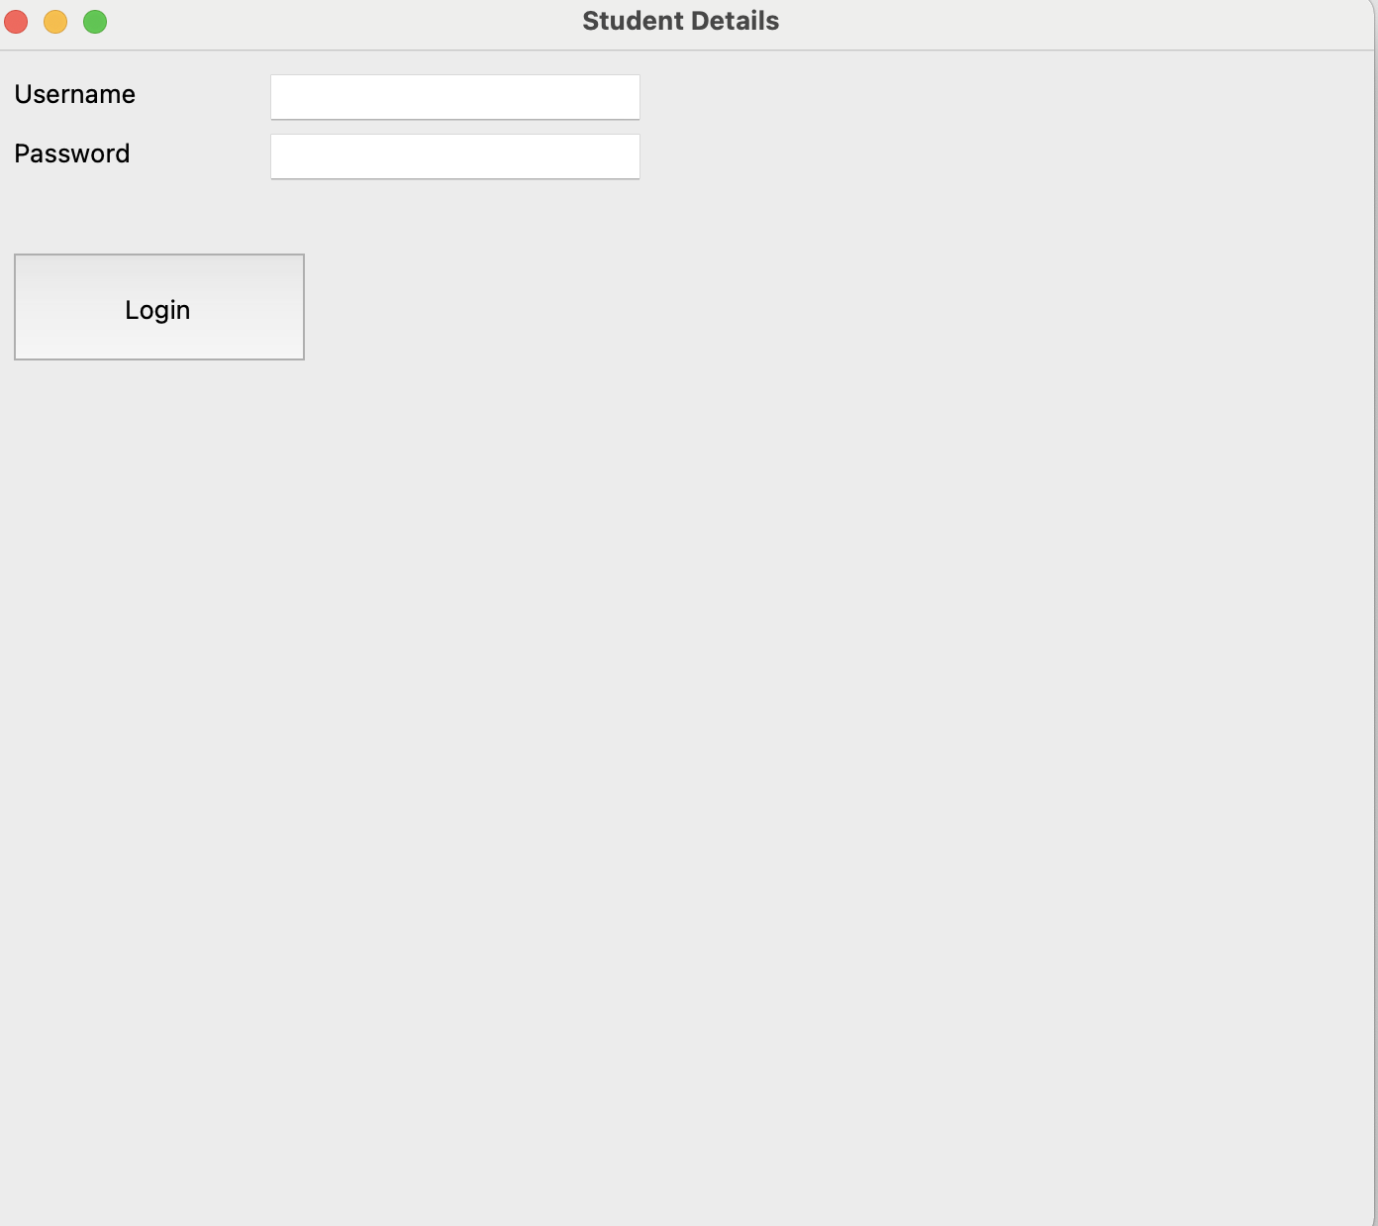

Login Page

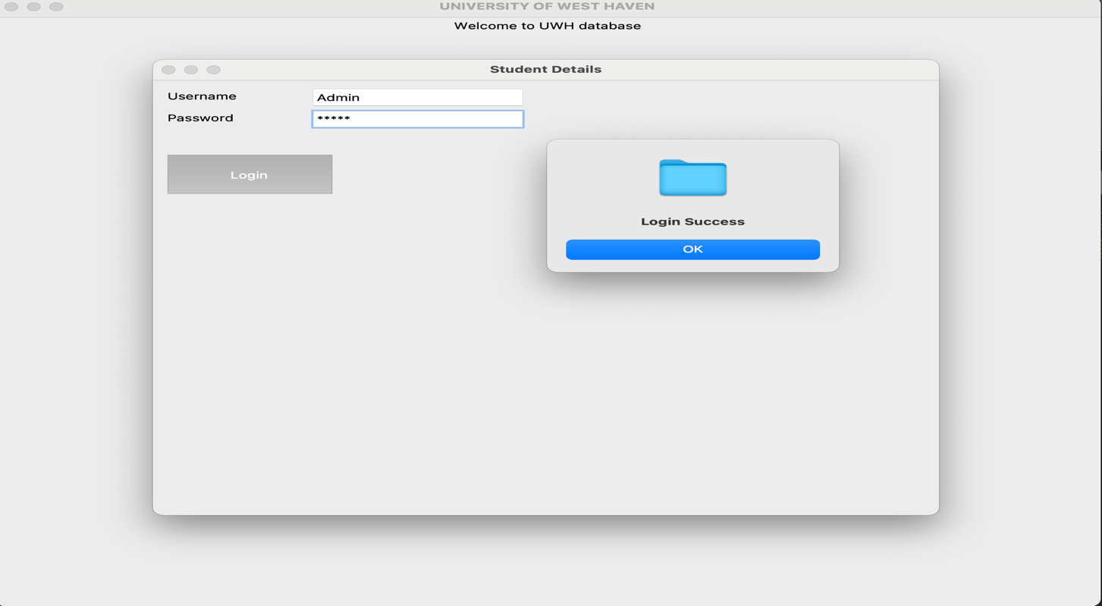

CRUD Operation in Student Section

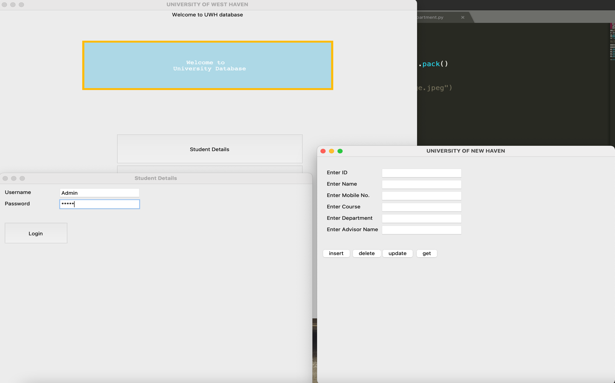

DB Result

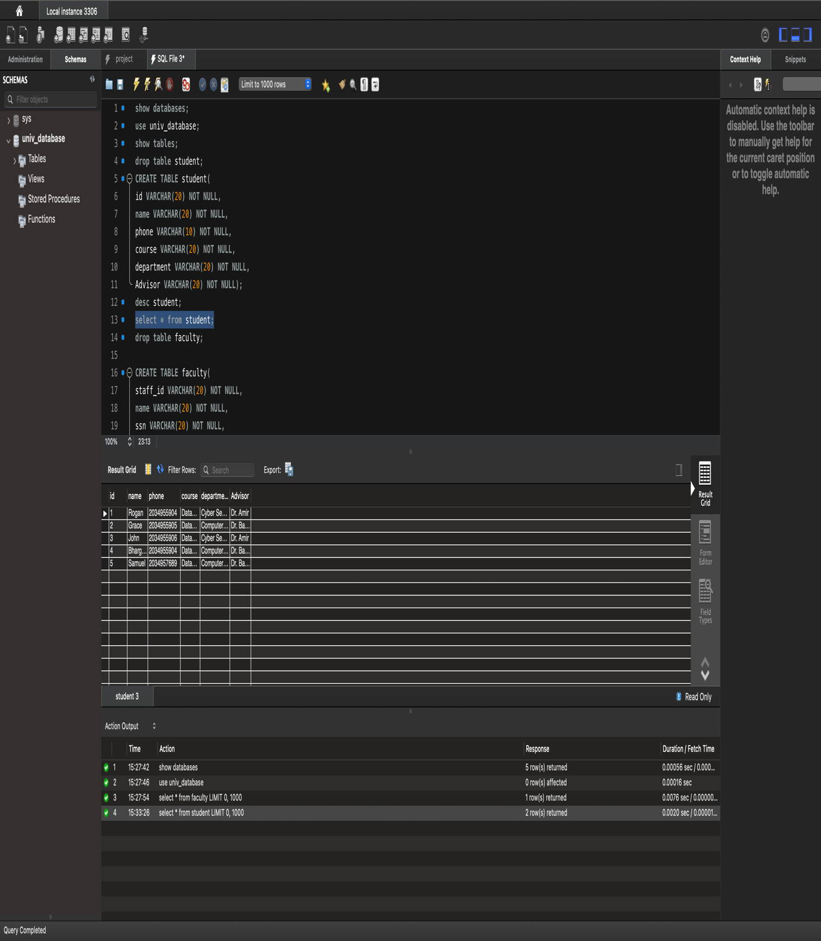

Faculty.py

**from** tkinter **import** *

**from** tkinter **import** messagebox

**import** mysql.connector **as** mysql

**def** identity():

uname= e1.get()

password=e2.get()

**if**(uname == "" **and** password == ""):

messagebox.showinfo("", "Please fill all fields")

**elif**(uname == "Admin" **and** password == "123456"):

messagebox.showinfo("", "Login Success")

details();

**else**:

messagebox.showinfo("", "Incorrect username and password")

**def** fac_login():

root = Tk()

root.title("Faculty Details")

root.minsize(width=500,height=500)

root.geometry("700x600")

**global** e1,e2

uname = Label(root,text="Username").place(x=10,y=10)

password = Label(root,text="Password").place(x=10,y=40)

e1 = Entry(root)

e1.place(x=140, y=10)

e2 = Entry(root)

e2.place(x=140, y=40)

e2.config(show="*")

Button(root, text="Login", command=identity, height =3, width = 13).place(x=10,y=100)

root.mainloop()

**def** details():

**global** f_staffid,f_name,f_ssn,f_dept,f_email

root = Tk()

root.title("UNIVERSITY OF NEW HAVEN")

root.minsize(width=500,height=500)

root.geometry("700x600")

staff_id = Label(root,text="Enter Staff ID").place(x=20,y=30)

name = Label(root,text="Enter Name").place(x=20,y=60)

ssn = Label(root,text="Enter SSN ").place(x=20,y=90)

department = Label(root,text="Enter Department").place(x=20,y=120)

email = Label(root,text="Enter Email").place(x=20,y=150)

f_staffid = Entry(root)

f_staffid.place(x=150, y=30)

f_name = Entry(root)

f_name.place(x=150, y=60)

f_ssn = Entry(root)

f_ssn.place(x=150, y=90)

f_ssn.config(show="*")

f_dept = Entry(root)

f_dept.place(x=150, y=120)

f_email = Entry(root)

f_email.place(x=150, y=150)

Button (root,text= "insert",command=insert).place(x=10, y=240)

Button (root,text= "delete",command=delete).place(x=80, y=240)

Button (root,text= "update",command=update).place(x=150, y=240)

Button (root,text= "get",command=get).place(x=230, y=240)

#list= Listbox(root)

#list.place(x=390,y=30)

#show();

root.mainloop()

**def** insert():

staff_id =f_staffid.get()

name=f_name.get()

ssn=f_ssn.get()

department=f_dept.get()

email=f_email.get()

**if**(staff_id =="" **or** name=="" **or** ssn==""**or** department==""**or** email==""):

messagebox.showinfo("Insert Status","All fields are required");

**else**:

con = mysql.connect(host="localhost", user="root", password="rootroot", database="univ_database")

cursor= con.cursor()

cursor.execute("insert into faculty values('"+ staff_id +"','"+ name +"', '"+ssn +"','"+ department +"','"+email +"')")

cursor.execute("commit")

con.close()

**def** update():

staff_id =f_staffid.get()

name=f_name.get()

ssn=f_ssn.get()

department=f_dept.get()

email=f_email.get()

**if**(staff_id =="" **or** name=="" **or** ssn=="" **or** department==""**or** email==""):

messagebox.showinfo("Update Status","All fields are required");

**else**:

con = mysql.connect(host="localhost", user="root", password="rootroot", database="univ_database")

cursor= con.cursor()

cursor.execute("update faculty set staff_id='"+staff_id+"',name='"+name+"',ssn='"+ssn+"',department='"+department+"',email='"+email+"' where staff_id = '"+ staff_id+"'")

cursor.execute("commit")

f_staffid.delete(0,'end')

f_name.delete(0,'end')

f_ssn.delete(0,'end')

f_dept.delete(0,'end')

f_email.delete(0,'end')

messagebox.showinfo("Update status","Update Successfully")

con.close()

**def** delete():

staff_id = f_staffid.get()

**if**(staff_id== ""):

messagebox.showinfo("Delete Status","ID is required");

**else**:

con = mysql.connect(host="localhost", user="root", password="rootroot", database="univ_database")

cursor= con.cursor()

cursor.execute("delete from faculty where staff_id = '"+ staff_id +"'")

cursor.execute("commit")

con.close()

**def** get():

**if**(f_staffid.get()==""):

messagebox.showinfo("Fetch status", "ID is compulsory to fetch details")

**else**:

con = mysql.connect(host="localhost", user="root", password="rootroot", database="univ_database")

cursor= con.cursor()

cursor.execute("select * from faculty where staff_id = '"+ f_staffid.get() +"'")

rows = cursor.fetchall()

**for** row **in** rows:

f_name.insert(0, row[1])

f_ssn.insert(0, row[2])

f_dept.insert(0, row[3])

f_email.insert(0, row[4])

con.close()

Output

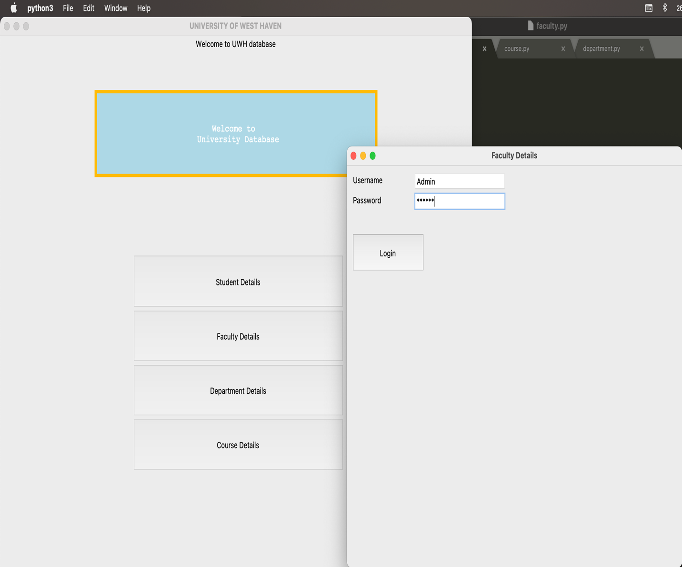

CRUD Operation in Faculty Section:

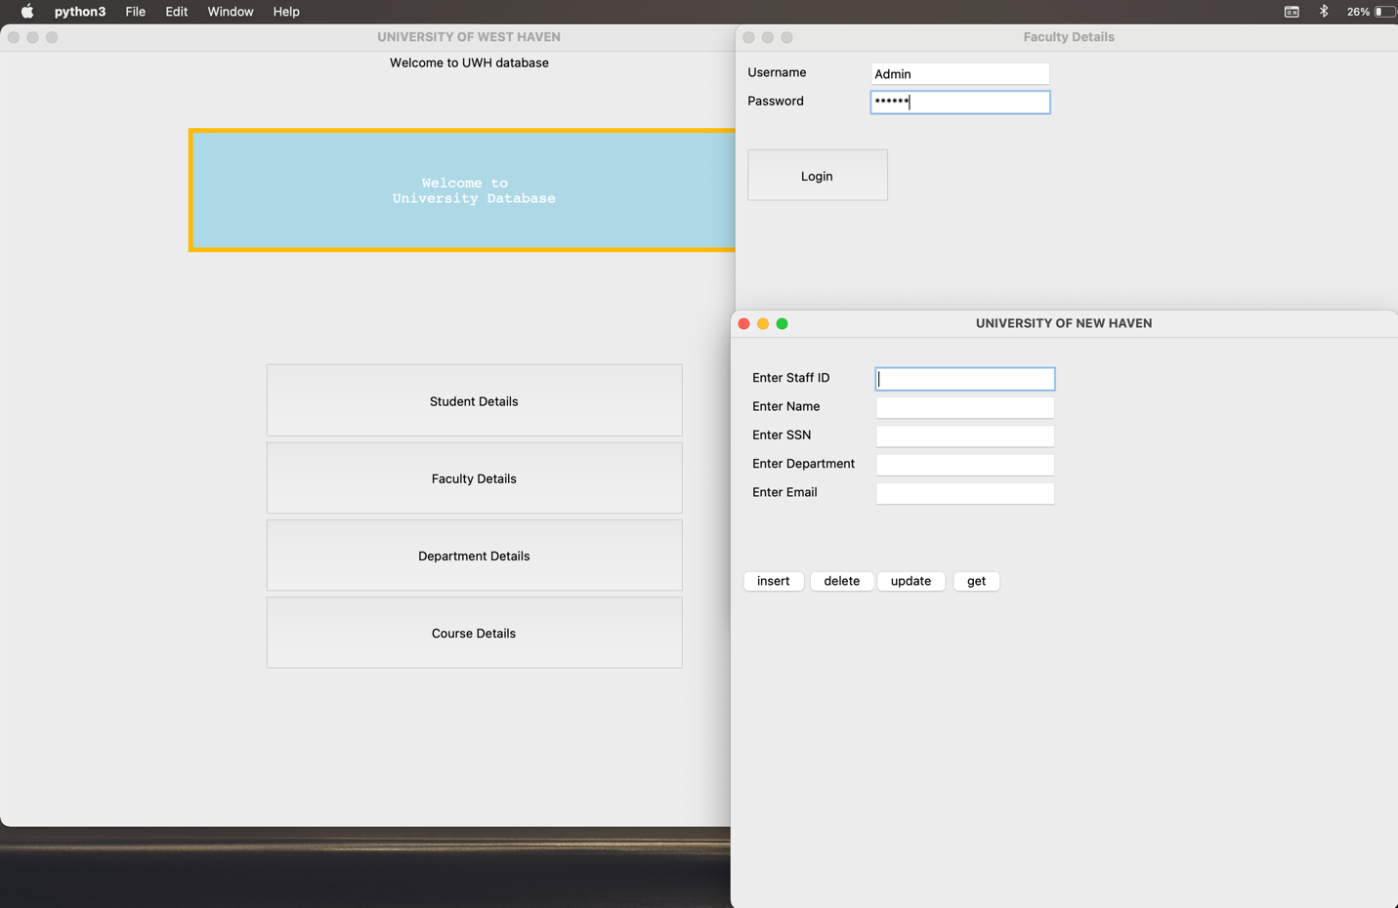

DB Output 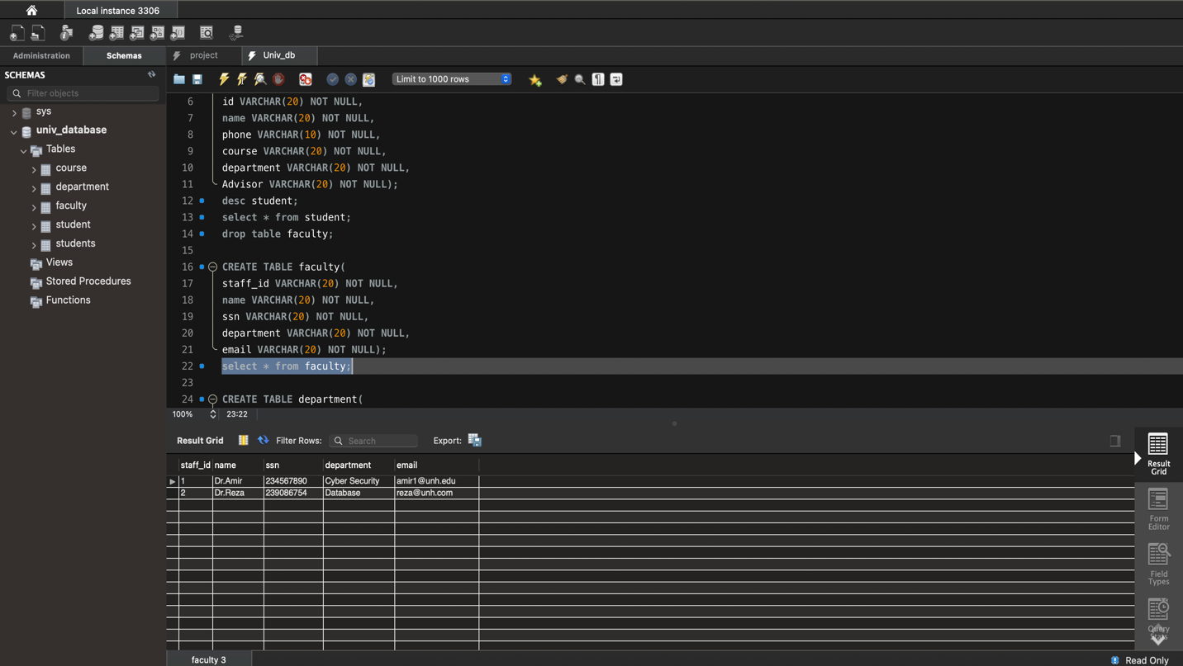

Department.py

**from** tkinter **import** *

**from** tkinter **import** messagebox

**import** mysql.connector **as** mysql

**def** identity():

uname= e1.get()

password=e2.get()

**if**(uname == "" **and** password == ""):

messagebox.showinfo("", "Please fill all fields")

**elif**(uname == "Admin" **and** password == "1234"):

messagebox.showinfo("", "Login Success")

details();

**else**:

messagebox.showinfo("", "Incorrect username and password")

**def** dep_login():

root = Tk()

root.title("Department Details")

root.minsize(width=500,height=500)

root.geometry("700x600")

**global** e1,e2

uname = Label(root,text="Username").place(x=10,y=10)

password = Label(root,text="Password").place(x=10,y=40)

e1 = Entry(root)

e1.place(x=140, y=10)

e2 = Entry(root)

e2.place(x=140, y=40)

e2.config(show="*")

Button(root, text="Login", command=identity, height =3, width = 13).place(x=10,y=100)

root.mainloop()

**def** details():

**global** d_deptid, d_name, d_email

root = Tk()

root.title("UNIVERSITY OF NEW HAVEN")

root.minsize(width=500,height=500)

root.geometry("700x600")

d_deptid = Label(root,text="Enter Department ID").place(x=20,y=30)

d_name = Label(root,text="Enter Department Name").place(x=20,y=60)

d_email = Label(root,text="Enter Department Email").place(x=20,y=90)

d_deptid = Entry(root)

d_deptid.place(x=150, y=30)

d_name = Entry(root)

d_name.place(x=180, y=60)

d_email = Entry(root)

d_email.place(x=180, y=90)

Button (root,text= "insert",command=insert).place(x=10, y=240)

Button (root,text= "delete",command=delete).place(x=80, y=240)

Button (root,text= "update",command=update).place(x=150, y=240)

Button (root,text= "get",command=get).place(x=230, y=240)

#list= Listbox(root)

#list.place(x=390,y=30)

#show();

root.mainloop()

**def** insert():

dept_id = d_deptid.get()

dept_name = d_name.get()

dept_email = d_email.get()

**if**(dept_id == "" **or** dept_name == "" **or** dept_email==""):

messagebox.showinfo("Insert Status","All fields are required")

**else**:

con = mysql.connect(host="localhost", user="root", password="rootroot", database="univ_database")

cursor= con.cursor()

cursor.execute("insert into department values('"+ dept_id +"','"+ dept_name +"','"+dept_email +"')")

cursor.execute("commit")

con.close()

**def** update():

dept_id = d_deptid.get()

dept_name = d_name.get()

dept_email = d_email.get()

**if**(dept_id =="" **or** dept_name =="" **or** dept_email==""):

messagebox.showinfo("Update Status","All fields are required");

**else**:

con = mysql.connect(host="localhost", user="root", password="rootroot", database="univ_database")

cursor= con.cursor()

cursor.execute("update department set dept_id='"+dept_id+"',dept_name='"+dept_name+"',dept_email='"+dept_email+"' where dept_id = '"+ dept_id+"'")

cursor.execute("commit")

dept_id.delete(0,'end')

dept_name.delete(0,'end')

dept_email.delete(0,'end')

messagebox.showinfo("Update status","Update Successfully")

con.close()

**def** delete():

dept_id = d_deptid.get()

**if**(dept_id== ""):

messagebox.showinfo("Delete Status","ID is required");

**else**:

con = mysql.connect(host="localhost", user="root", password="rootroot", database="univ_database")

cursor= con.cursor()

cursor.execute("delete from department where dept_id = '"+ dept_id +"'")

cursor.execute("commit")

con.close()

**def** get():

**if**(d_deptid.get()==""):

messagebox.showinfo("Fetch status", "ID is compulsory to fetch details")

**else**:

con = mysql.connect(host="localhost", user="root", password="rootroot", database="univ_database")

cursor= con.cursor()

cursor.execute("select * from department where dept_id = '"+ d_deptid.get() +"'")

rows = cursor.fetchall()

**for** row **in** rows:

d_name.insert(0, row[1])

d_email.insert(0, row[2])

con.close()

Output

Login for Faculty

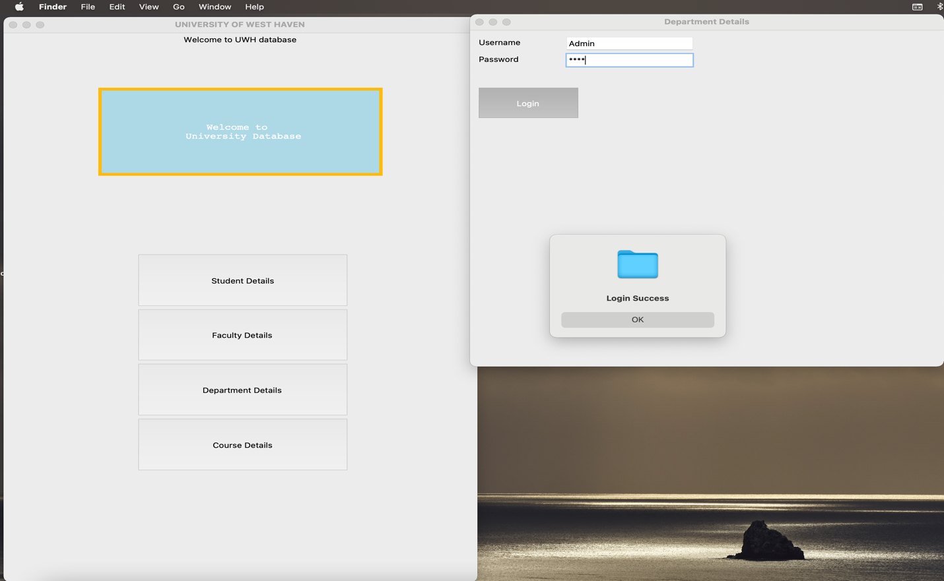

CRUD for Faculty Section

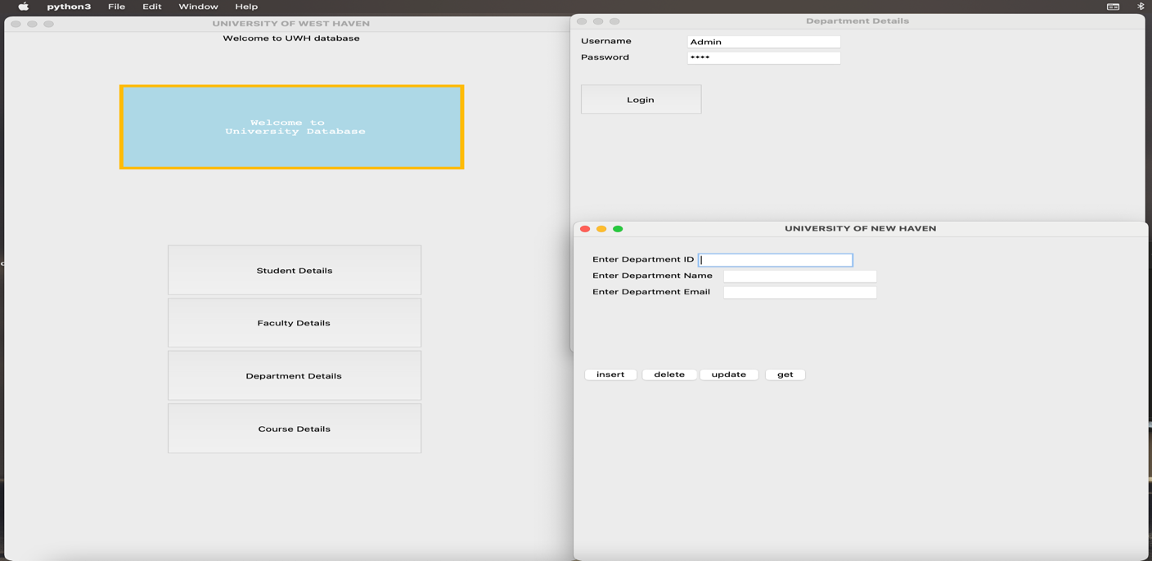

DB Output

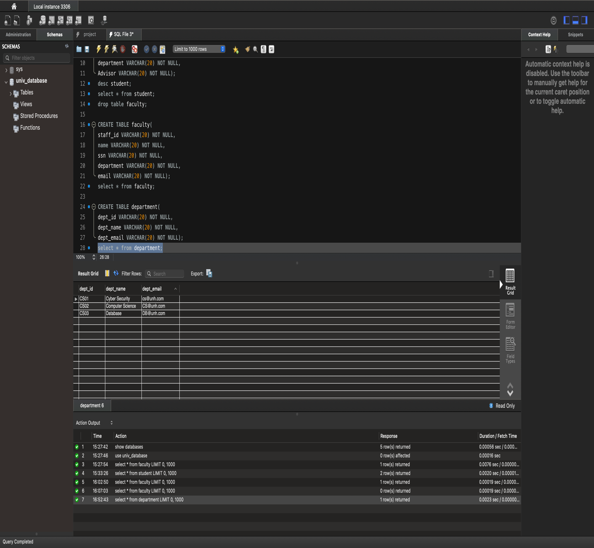

Course.py

**from** tkinter **import** *

**from** tkinter **import** messagebox

**import** mysql.connector **as** mysql

**def** identity():

uname= e1.get()

password=e2.get()

**if**(uname == "" **and** password == ""):

messagebox.showinfo("", "Please fill all fields")

**elif**(uname == "Admin" **and** password == "1243"):

messagebox.showinfo("", "Login Success")

details();

**else**:

messagebox.showinfo("", "Incorrect username and password")

**def** course_login():

root = Tk()

root.title("Course Details")

root.minsize(width=500,height=500)

root.geometry("700x600")

**global** e1,e2

uname = Label(root,text="Username").place(x=10,y=10)

password = Label(root,text="Password").place(x=10,y=40)

e1 = Entry(root)

e1.place(x=140, y=10)

e2 = Entry(root)

e2.place(x=140, y=40)

e2.config(show="*")

Button(root, text="Login", command=identity, height =3, width = 13).place(x=10,y=100)

root.mainloop()

**def** details():

**global** c_cid, c_cname, c_cterm, c_cfaculty, c_ctime

root = Tk()

root.title("UNIVERSITY OF NEW HAVEN")

root.minsize(width=500,height=500)

root.geometry("700x600")

c_cid = Label(root,text="Enter Course ID").place(x=20,y=30)

c_cname = Label(root,text="Enter Course Name").place(x=20,y=60)

c_cterm = Label(root,text="Enter Course Term ").place(x=20,y=90)

c_cfaculty = Label(root,text="Enter Faculty Name").place(x=20,y=120)

c_ctime = Label(root,text="Enter Course Time").place(x=20,y=150)

c_cid= Entry(root)

c_cid.place(x=150, y=30)

c_cname = Entry(root)

c_cname.place(x=180, y=60)

c_cterm = Entry(root)

c_cterm.place(x=180, y=90)

c_cfaculty = Entry(root)

c_cfaculty.place(x=180, y=120)

c_ctime = Entry(root)

c_ctime.place(x=180, y=150)

Button (root,text= "insert",command=insert).place(x=10, y=240)

Button (root,text= "delete",command=delete).place(x=80, y=240)

Button (root,text= "update",command=update).place(x=150, y=240)

Button (root,text= "get",command=get).place(x=230, y=240)

#list= Listbox(root)

#list.place(x=390,y=30)

#show();

root.mainloop()

**def** insert():

course_id = c_cid.get()

course_name = c_cname.get()

course_term = c_cterm .get()

course_faculty = c_cfaculty.get()

course_time = c_ctime.get()

**if**(course_id =="" **or** course_name =="" **or** course_term ==""**or** course_faculty ==""**or** course_time==""):

messagebox.showinfo("Insert Status","All fields are required");

**else**:

con = mysql.connect(host="localhost", user="root", password="rootroot", database="univ_database")

cursor= con.cursor()

cursor.execute("insert into course values('"+ course_id+"','"+ course_name +"', '"+ course_term +"','"+ course_faculty +"','"+course_time+"')")

cursor.execute("commit")

con.close()

**def** update():

course_id = c_cid.get()

course_name = c_cname.get()

course_term = c_cterm .get()

course_faculty = c_cfaculty.get()

course_time = c_ctime.get()

**if**(course_id =="" **or** course_name =="" **or** course_term ==""**or** course_faculty ==""**or** course_time==""):

messagebox.showinfo("Update Status","All fields are required");

**else**:

con = mysql.connect(host="localhost", user="root", password="rootroot", database="univ_database")

cursor= con.cursor()

cursor.execute("update course set course_id='"+course_id+"',course_name='"+course_name+"',course_term ='"+course_term+"',course_faculty ='"+course_faculty+"',course_time ='"+course_time+"' where course_id = '"+ course_id+"'")

cursor.execute("commit")

course_id.delete(0,'end')

course_name.delete(0,'end')

course_term.delete(0,'end')

course_faculty.delete(0,'end')

course_time.delete(0,'end')

messagebox.showinfo("Update status","Update Successfully")

con.close()

**def** delete():

course_id = c_cid.get()

**if**(course_id== ""):

messagebox.showinfo("Delete Status","ID is required");

**else**:

con = mysql.connect(host="localhost", user="root", password="rootroot", database="univ_database")

cursor= con.cursor()

cursor.execute("delete from course where course_id = '"+ course_id +"'")

cursor.execute("commit")

con.close()

**def** get():

**if**(c_cid.get()==""):

messagebox.showinfo("Fetch status", "ID is compulsory to fetch details")

**else**:

con = mysql.connect(host="localhost", user="root", password="rootroot", database="univ_database")

cursor= con.cursor()

cursor.execute("select * from course where course_id = '"+ c_cid.get() +"'")

rows = cursor.fetchall()

**for** row **in** rows:

c_cname.insert(0, row[1])

c_cterm.insert(0, row[2])

c_cfaculty.insert(0, row[3])

c_ctime.insert(0, row[4])

con.close()

Output

Login page for Course Details

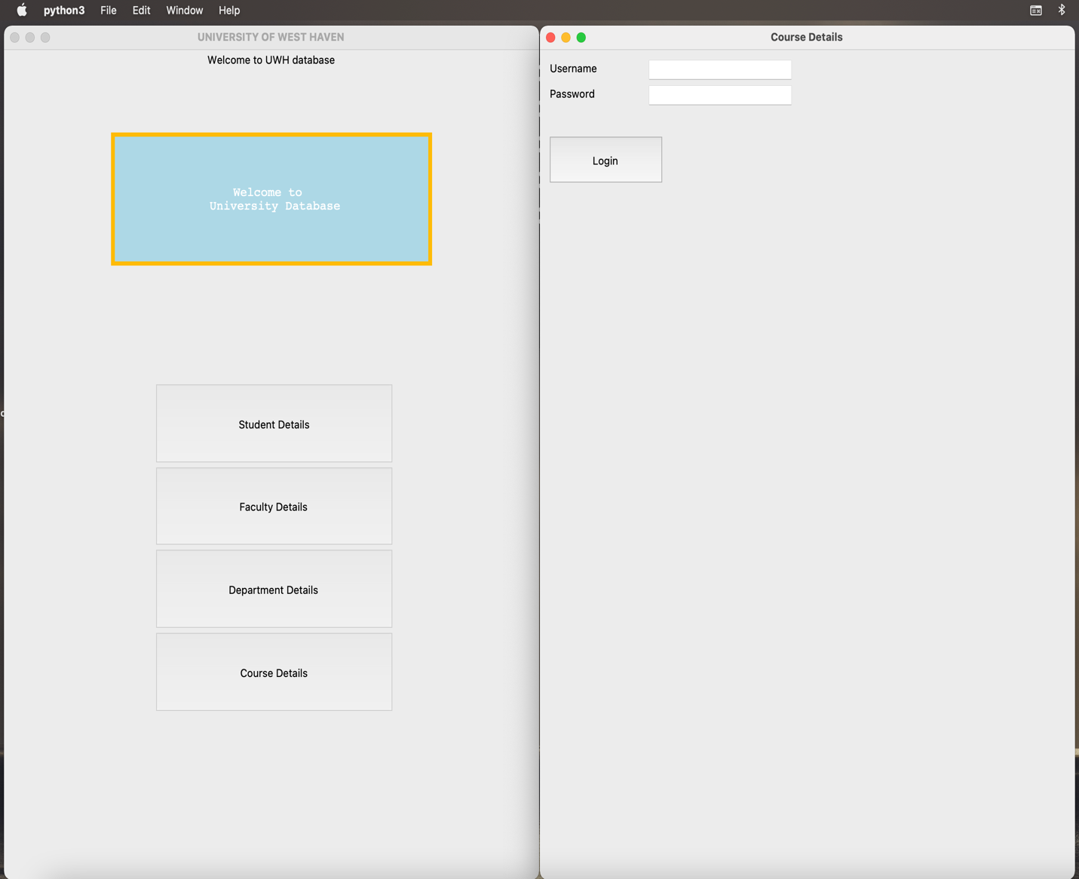

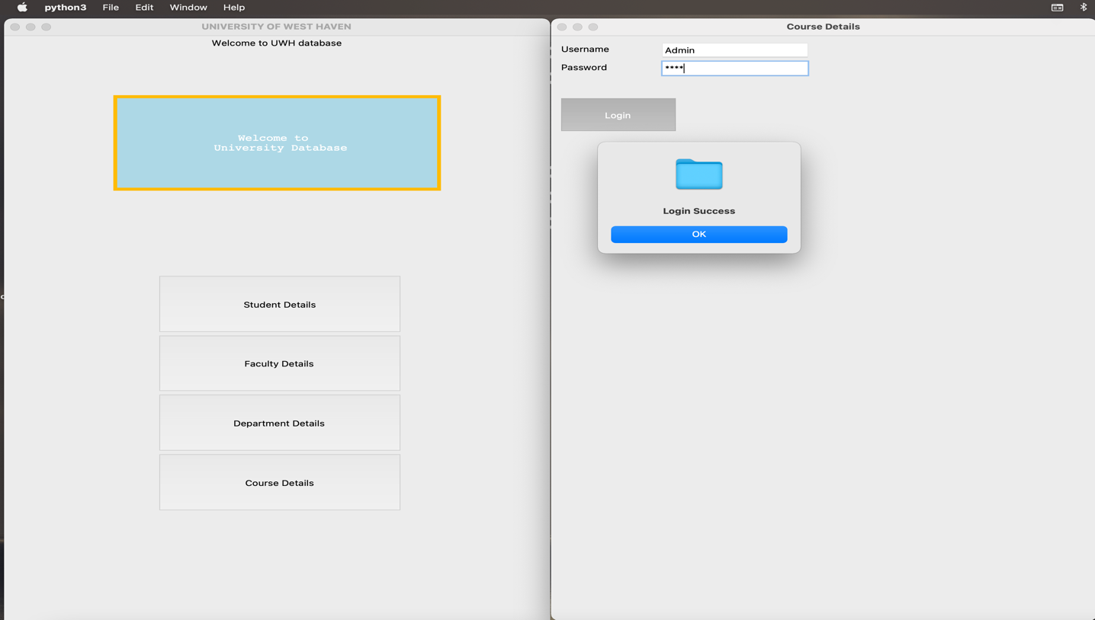CRUD Operation

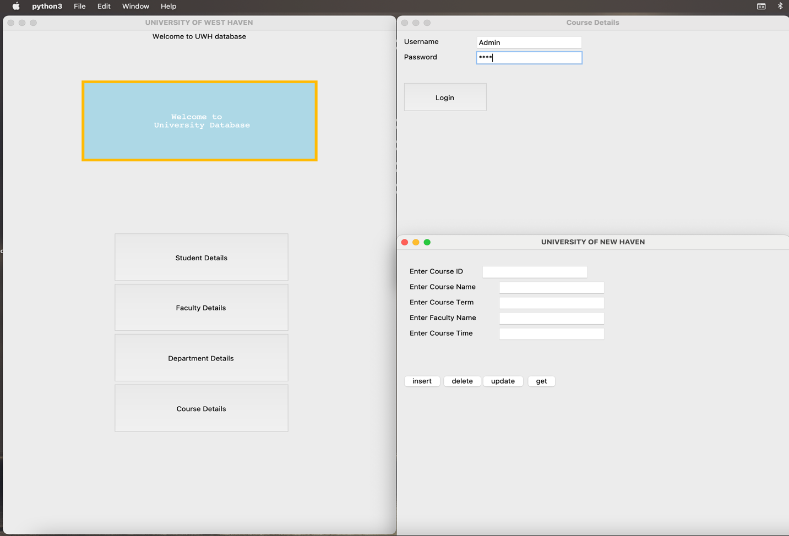

DB Result

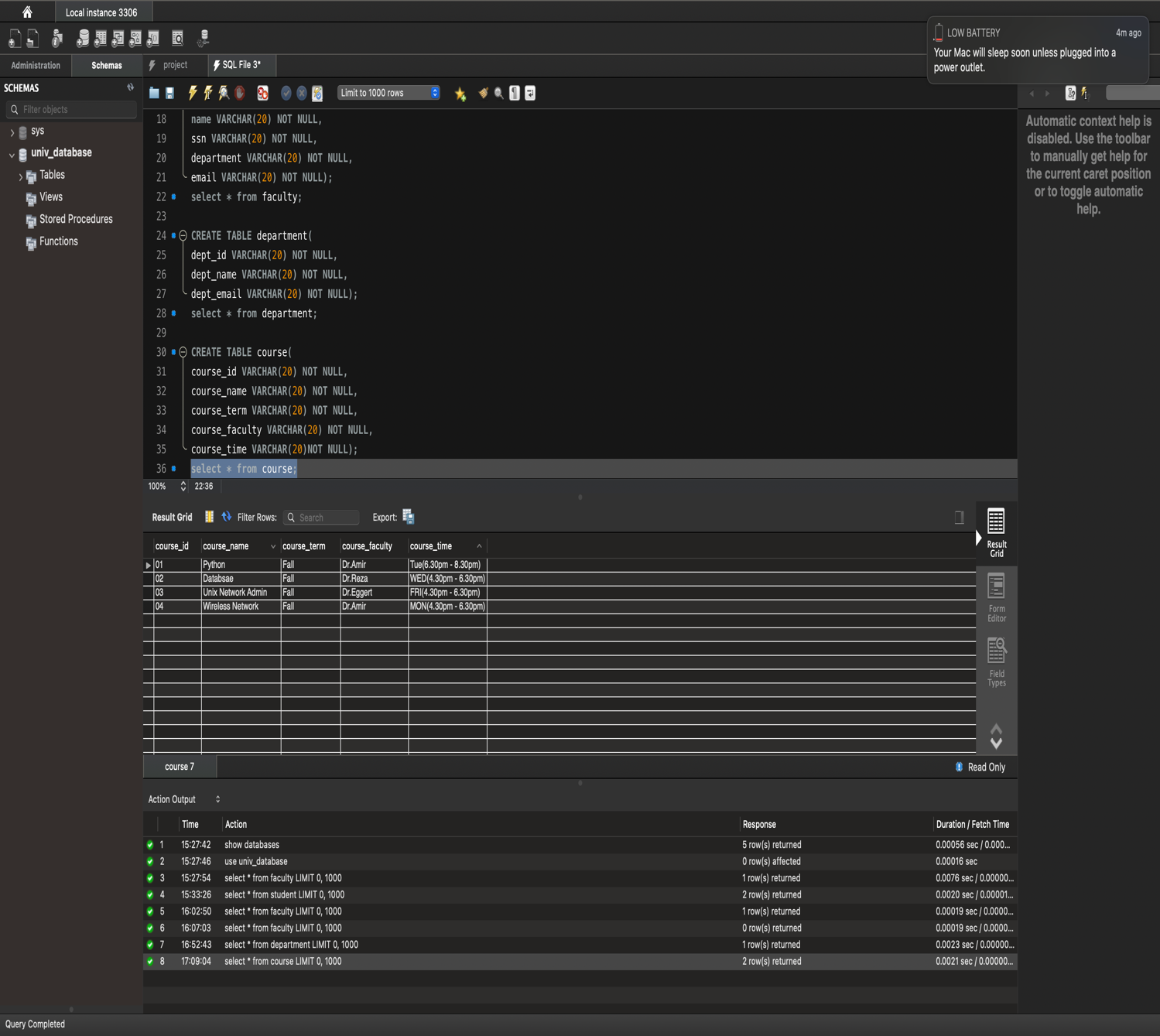

Conclusion:

The university database was successfully created and implemented using the GUI. In future, this database will be implemented with some more details and will be hosted in the internet to be accessed by everyone with added security features.